Bryan Cabrera

4/21/2024

Module 6 Assignment

**Several lines after script is ran:**

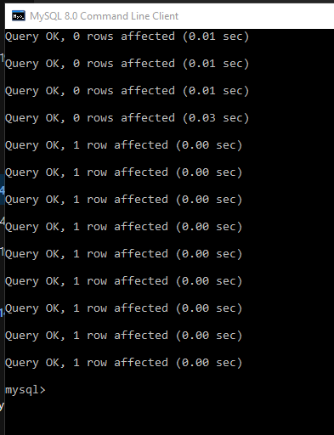

**SHOW TABLES:**

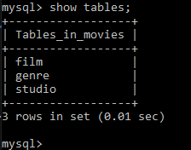

**Python Script in Command Prompt:**

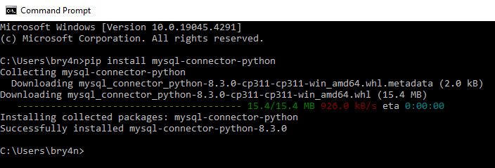

**Python Script in Command Prompt**(ran it then fixed error, ran again)**:**

